Second Quarter Book Report
Fancy Folder

The second assigned book report will be a “Fancy Folder.” The requirement will be a fiction book from the school reading list for 4th, 5th, or 6th grades. This book needs to be 100 pages or more. Books must be chosen and approved by parents and teacher by Tuesday, October 23rd to allow plenty of time for students to both read and complete the assignment by the due date. Directions on how to complete this book report and a rubric are attached.
You will find a complete listing of the school’s approved reading list on Painted Rock’s Website. Go to Parents which is on the top left of the webpage. Scroll down and click on Reading Lists. Then click on fourth grade. If you do not have access to a computer to view the list on-line, please ask your teacher and one will be given to you.
Remember don’t wait to the last week to do your project.
Friday, December 7th – Final Book Report Due

Fancy Folder Book Approval Form
Please detach before submission. Retain the instructions pages for your reference.
Name
Title of book and Series (if applicable)
Grade Level _______________________________________________
Author
Number of pages Parent approval
Teacher approval Date approved

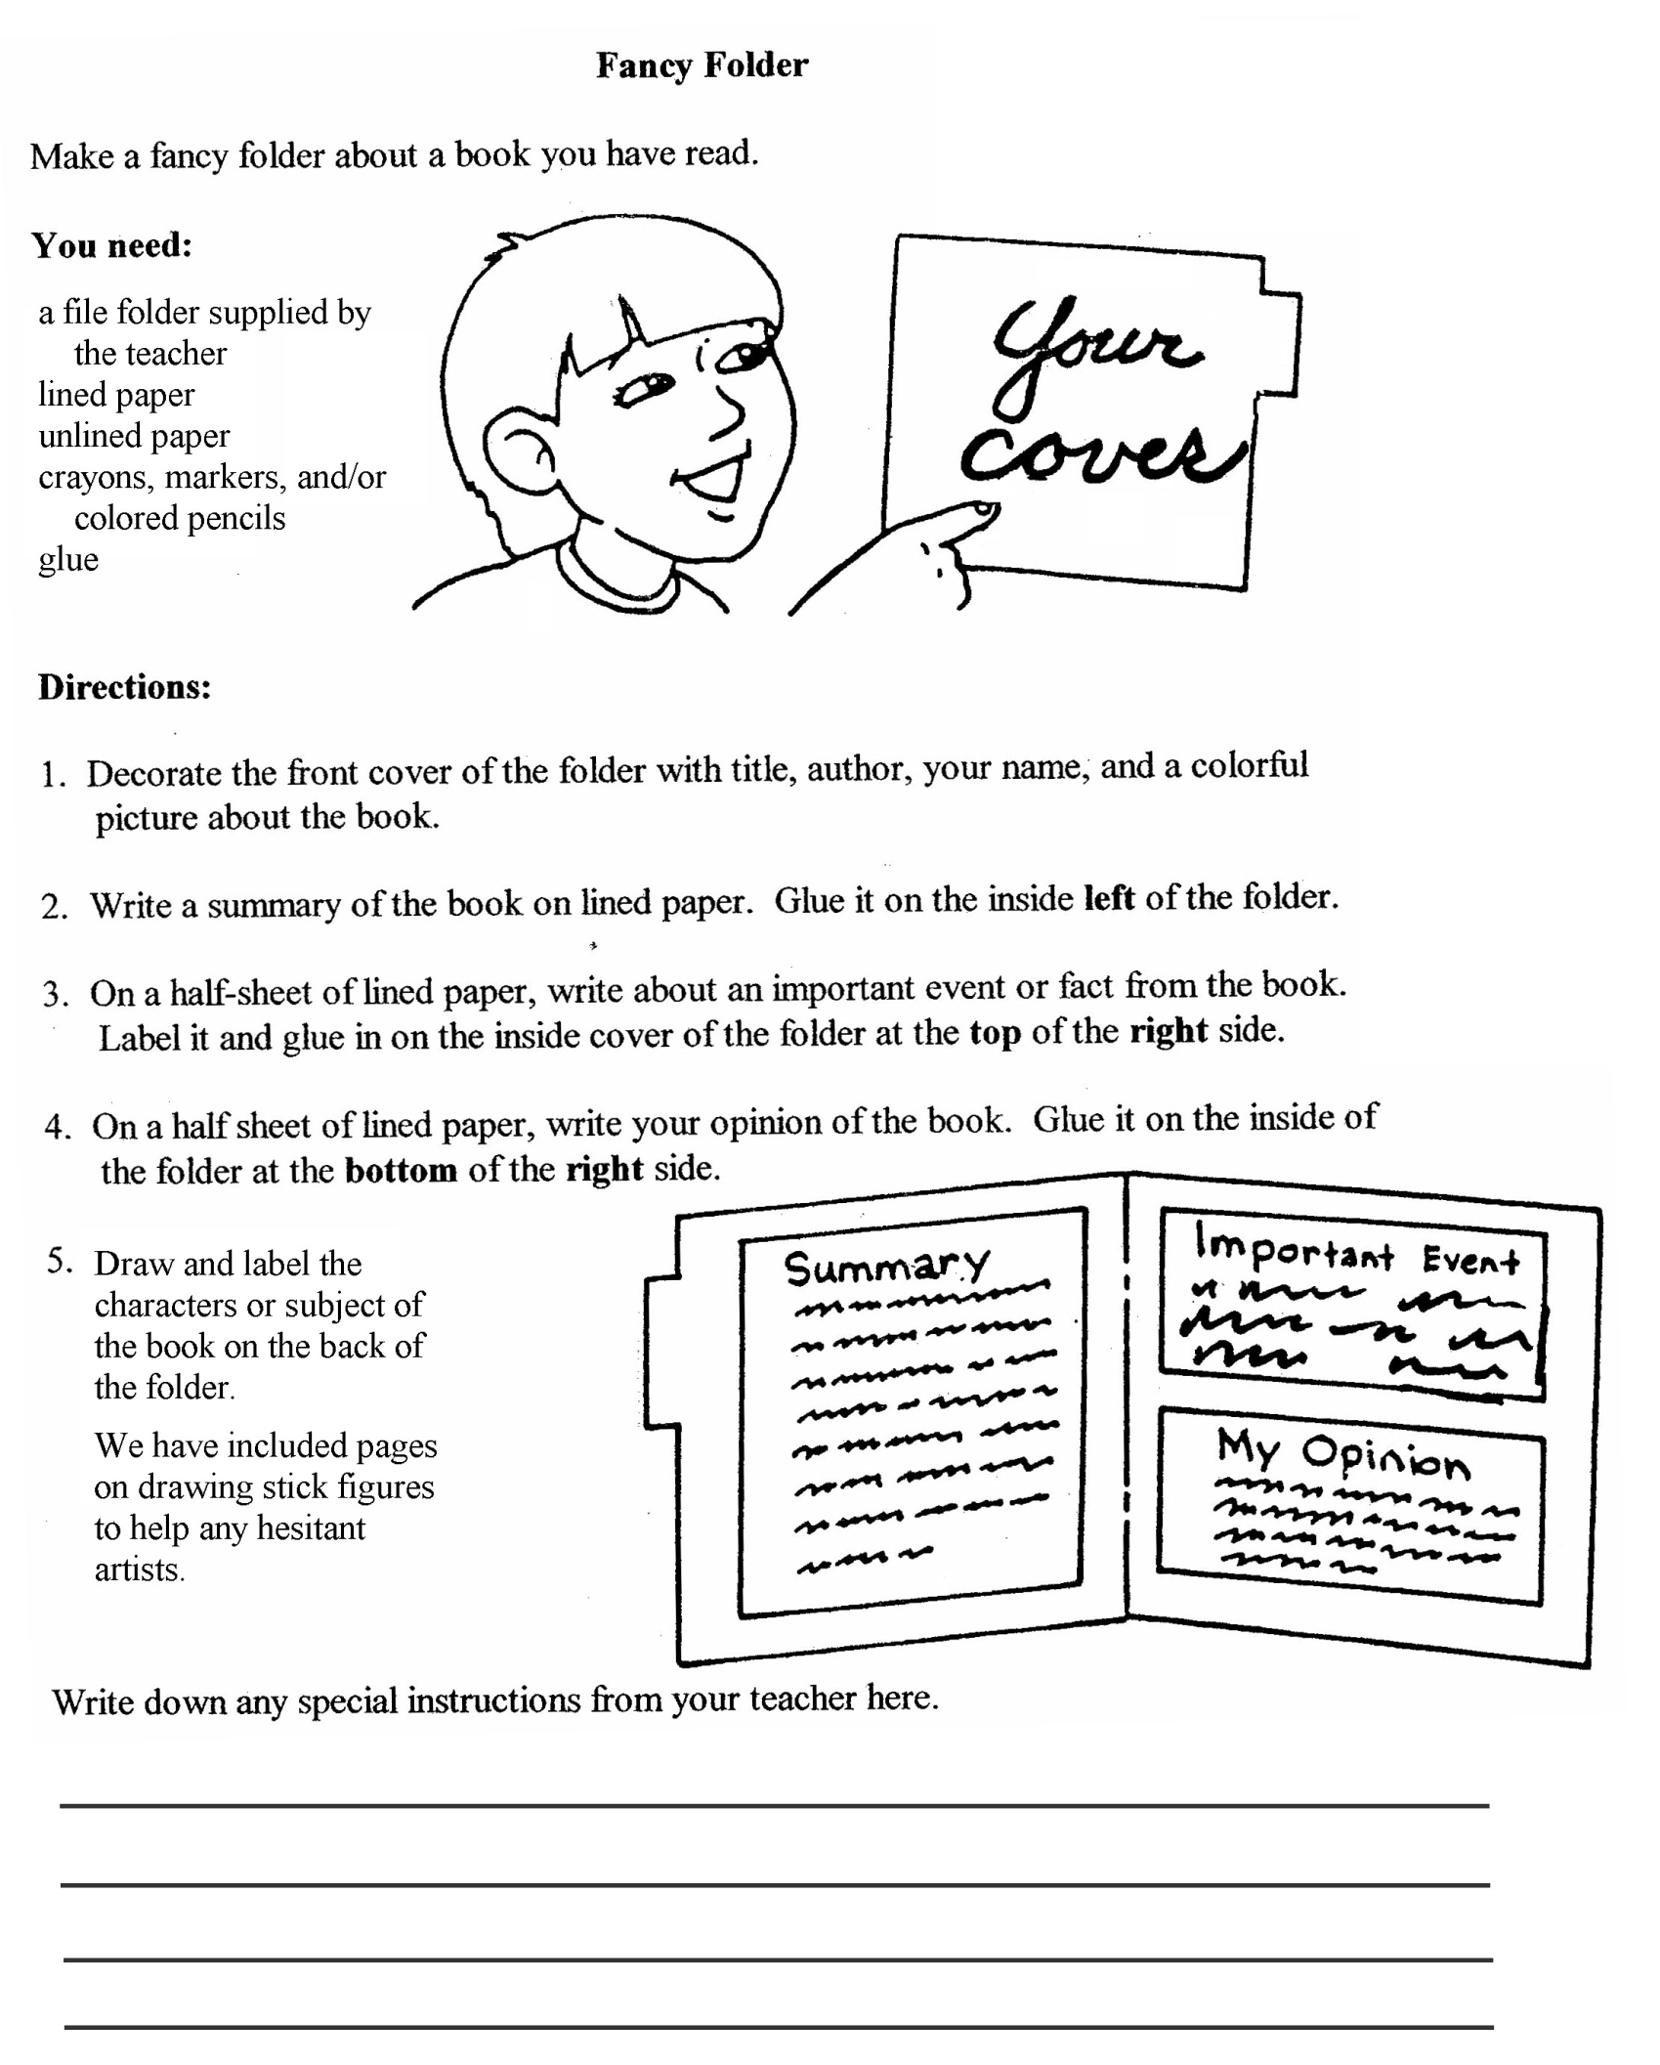

Fancy Folder Book Report Rubric

Please return this sheet with the final project on December 7^{th.}

Summary – 20 points possible
Content - 8 to 10 sentences
Punctuation/grammar
Spelling

Important event – 20 points possible
Content – The event is important to the story 6 to 8 sentences
Punctuation/grammar
Spelling

Opinion – 20 points possible
Content - 5 sentences with details
Punctuation/grammar
Spelling

Front Cover – 10 points possible
Colorful/neat
Title/Author
Spelling
Student’s name

Back Cover – 10 points possible
Colorful/neat
Drawings of characters labeled
Spelling

Handwriting – 10 points possible
Spalding Cursive
Neat and easy to read

Six Traits Writing Score—10 points possible ___________
Ideas are detailed and provide important information
Organization is evident. Paragraphs include topic sentences, supporting details,
transition words, and concluding sentences

Total /100

